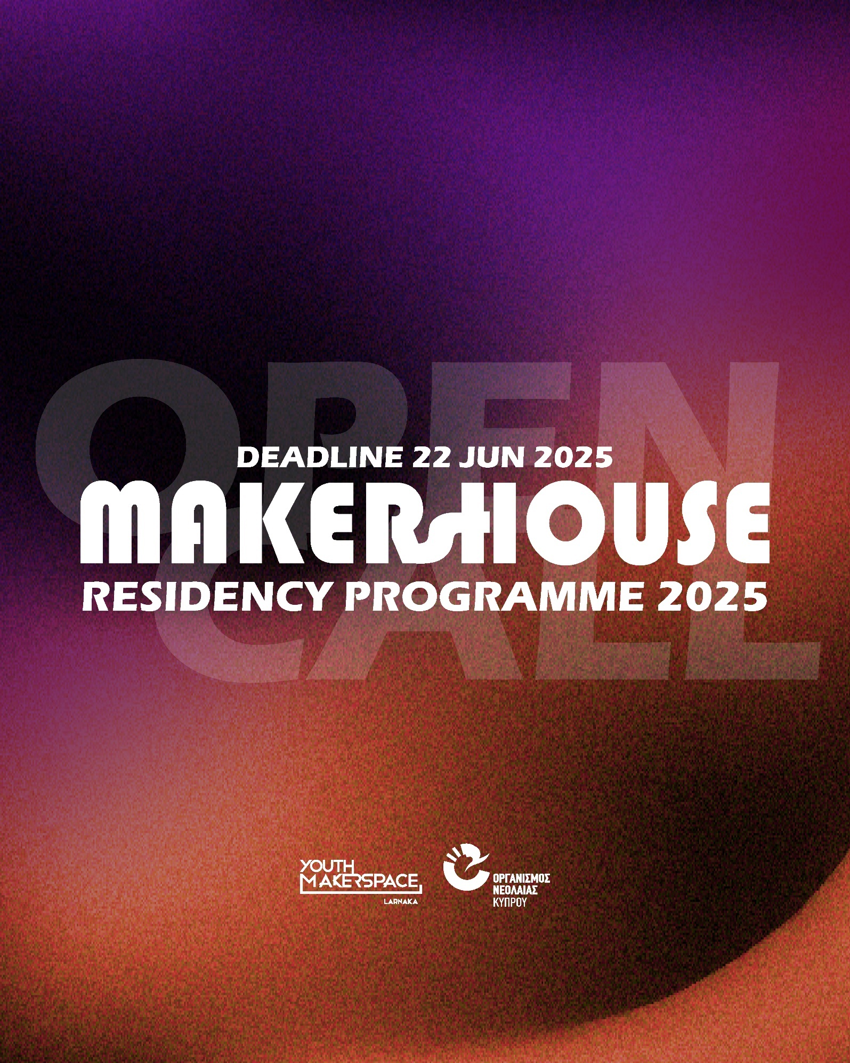

|  |
| --- |
| **PROPOSAL APPLICATION**  **IDEA DESCRIPTION AND IMPLEMENTATION METHODOLOGY** |
| 1. **Residency idea description: *(Maximum words: 1000)*** |

***Describe the purpose of the idea, the implementation plan and the implementation methodology with particular emphasis on the construction and presentation methods. Please, also mention the workshops and/or rooms of the Youth Makerspace Larnaka that might be used during the residency and the additional equipment you may need.***

***See our space and equipment here:*** [**https://makerspace.onek.org.cy/eksoplismos/**](https://makerspace.onek.org.cy/eksoplismos/)

|  |
| --- |
| Expected results, social and technological impact of the activity: *(Maximum words: 500)* |

***Describe the expected social and technological impact of your idea – activity with emphasis on the youth. Also note the expected results.***

|  |
| --- |
| Residency Visual Material: *(Maximum pages: 3)* |

***Please attach 2-5 photos/sketches/diagrams related to the description of your proposal.***

|  |
| --- |
| Final Presentation of Residency: *(Maximum words: 500)* |

***Describe the final presentation of the Residency giving a title to the presentation and the character it will have (e.g. Music Performance, Art Exhibition, Workshop, Event, etc.) as well as its duration.***

|  |
| --- |
| **CURRICULUM VITAE OF INDIVIDUAL OR TEAM MEMBER** |

|  |
| --- |
| 1. **Description of the individual/team member *(Maximum words: 500 per person)*** |

***In addition to the description, please attach a short CV for each person/team member who will participate in the Residency. Attach your complete CV at the end of this application.***

|  |
| --- |
| 1. **Role of each team member *(Maximum words: 500)*** |

***To be completed in case of a group residency. Define and explain the role of each member in the team and in the implementation of the idea.***

**EVALUATION CRITERIA**

|  |  |  |
| --- | --- | --- |
| **Type of criterion** | **Importance (%)** | **Evaluator Scores (Maximum Score)** |
| **Quality of design, implementation, and technological methods of construction** | **35** | **7** |
| **Completeness and adequacy of the implementation plan** |
| **Clear and understandable description of an activity idea based on the objectives of the program** |
| **Definition of methodology and equipment** |
| **Aim and innovation of the project** | **35** | **7** |
| **Degree of innovation** |
| **Correlation of the Residency to the goals and actions of the Youth Makerspace Larnaka** |
| **Degree of feasibility** |
| **Impact expected program results** | **30** | **6** |
| **How to inform and promote results (event)** |
| **Social and technological impact of the results of the activity with emphasis on young people** |
| **Areas of application**  **Deliverable** |
| **TOTAL** | **100** | **20** |
| **FINAL GRADE (%)** |  | **100** |